1. Creating and Renaming Files/Directories
Create a directory named test_dir using mkdir.
Command used: mkdir test_dir
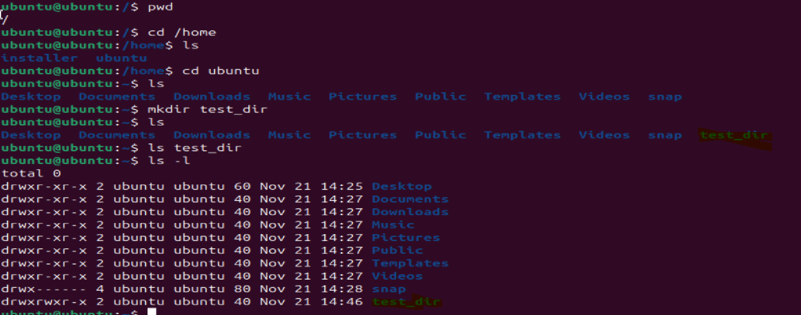
Inside test_dir, create an empty file called example.txt.
Command used: touch example.txt
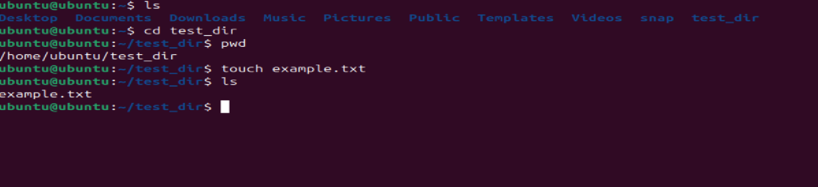
Rename example.txt to renamed_example.txt using mv
Command used: mv example.txt renamed_example.txt
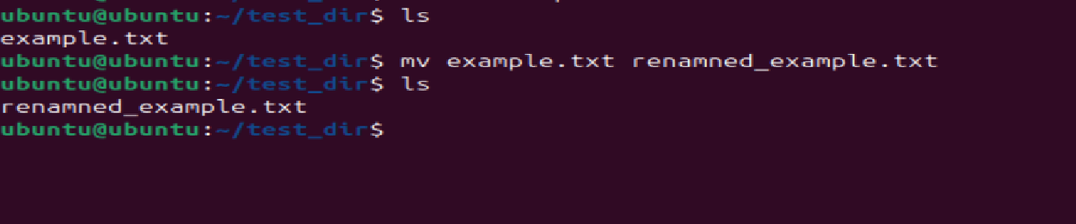
2. Viewing File Contents
Use cat to display the contents of /etc/passwd.
Command : Cat /etc/passwd
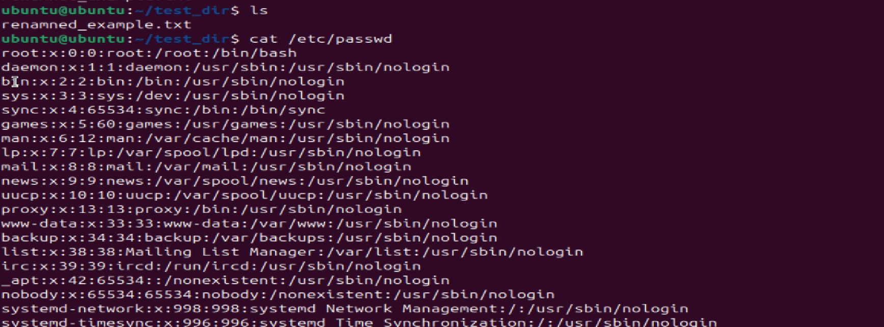
Display only the first 5 lines of /etc/passwd using head.
Command used: cat /etc/passwd | head -5
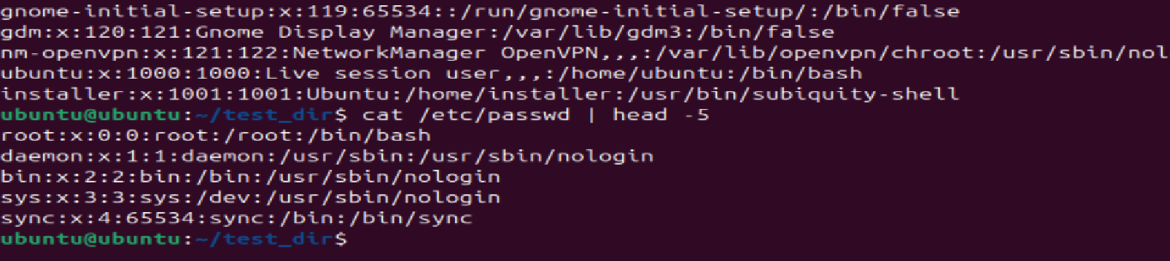
Display only the last 5 lines of /etc/passwd using tail.
Command used: cat /etc/passwd | tail -5
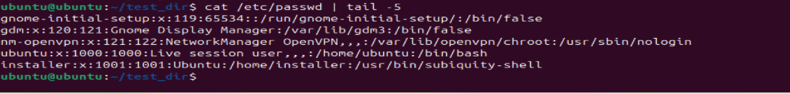
3.Searching for Patterns
Use grep to find all lines containing the word "root" in /etc/passwd.
Command used: cat /etc/passwd | grep root or cat /etc/passwd | grep –n root
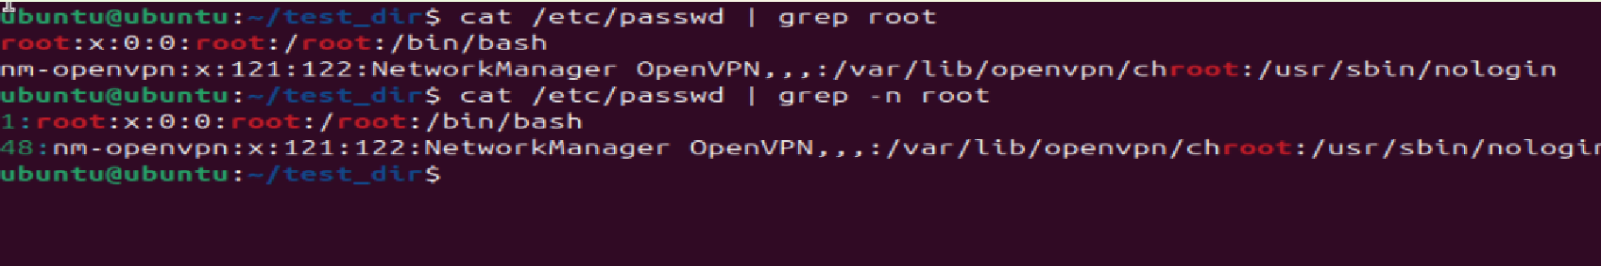

4. Zipping and Unzipping
Compress the test_dir directory into a file named test_dir.zip using zip.
Command used: zip test_dir.zip test_dir
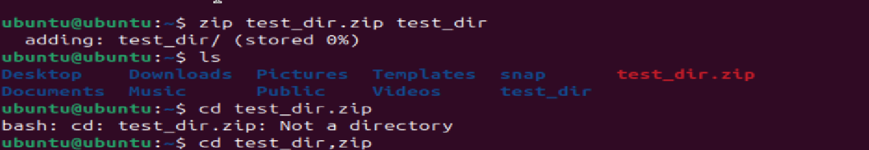
Unzip test_dir.zip into a new directory named unzipped_dir.
Command used: unzip test-dir.zip –d unziped_dir
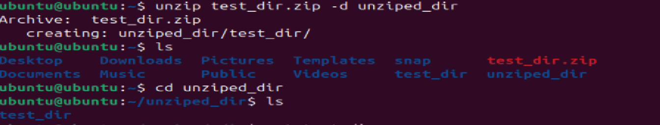

5. Downloading Files
Use wget to download a file from a URL (e.g., https://example.com/sample.txt).
Command used: wget –b https://example.com/sample.txt)
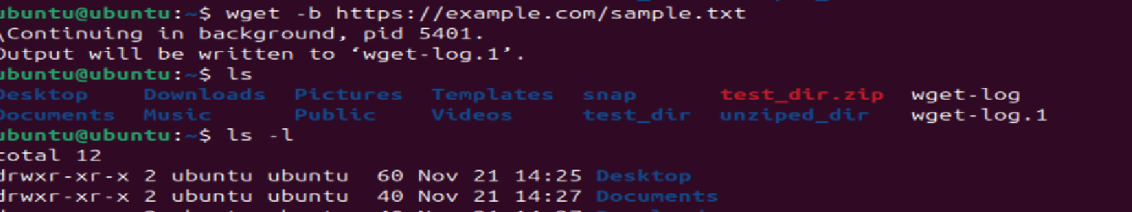
6. Changing Permissions
Create a file named secure.txt and change its permissions to read-only for everyone using chmod.
Command used: chomd 444 secure.txt
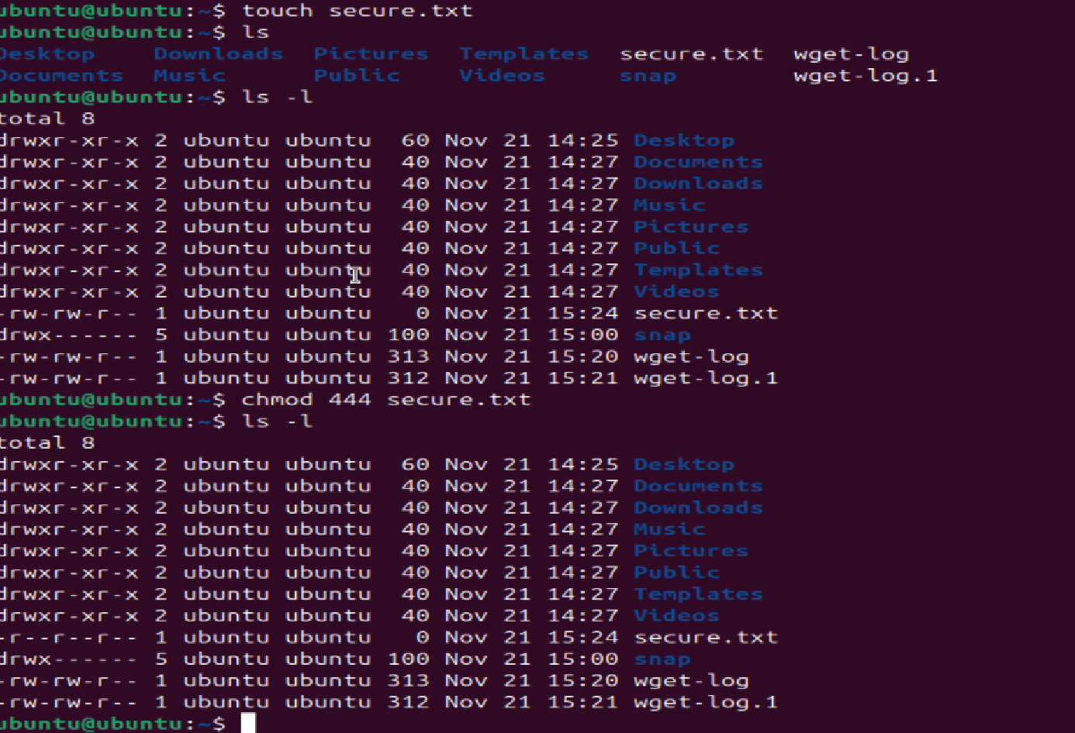

7. Working with Environment Variables
Use export to set a new environment variable called MY_VAR with the value "Hello, Linux!".
Command used: export MY_VAR=”Hello Linux”!

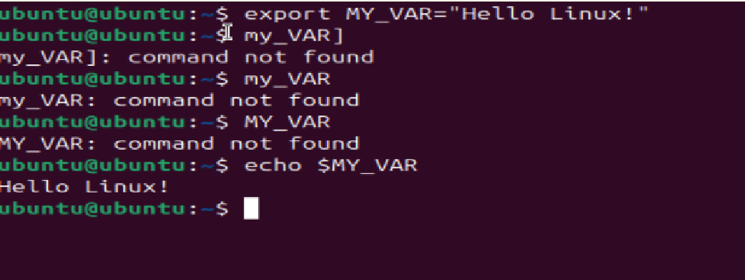

Submission Guidelines -: Attach Screenshots or command along with explanation and submit in doc(google doc or microsoft doc) format also attach github repo link

